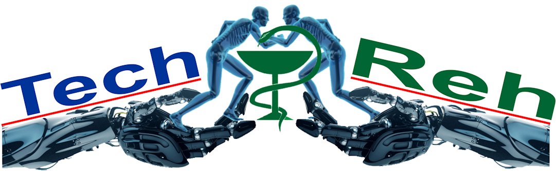

**KA2 - Cooperation for innovation and the exchange of good Practices**

**Capacity Building in Higher Education**

**Technology in Rehabilitation (TechReh)**

*561621-EPP-1-2015-1-IT-EPPKA2-CBHE-JP*

**Open Conference in Uzbekistan**

**Tashkent – Nukus 2016**

Tashkent – 2016

**TechReh Open Conference in Uzbekistan**

**14-20 November 2016**

**Draft schedule**

|  |  |  |  |
| --- | --- | --- | --- |
| **№** | **Event** | **Date** | **Comments** |
|  | EU partners arrival to Uzbekistan (Tashkent) | 14-15th | All visitors will be met at the airport by UZ organizers |
|  | 1st Workshop meeting at the RSSPMCTR (Tashkent) | 15th | All partners and stakeholders of the Project will participate in the seminar |
|  | Seminar on main topics of TechReh in TUIT + curricula development workshop | 16th | Business meetings with the rectors (vice rectors) of the TUIT will be organized |
|  | Project Consortium meeting +  Departure to Nukus | 17th | Business meetings with the rectors (vice rectors) of the TPMI will be organized |
|  | Dissemination event (Round Table) with stakeholders about Technology, ICT and Health Science, Medicine and Rehabilitation + Project Consortium meeting (future plans) | 18th | Preparation of proposals for TechReh project success |
|  | Participation in the anniversary of the NUKPEMI branch with presentations from EU Partners in their field of expertise + General Presentation about TechReh + departure to Tashkent | 19th | Presentation of the TechReh in anniversary of the NUKPEMI branch by one of the EU Partners |
|  | Departure of Participants from Tashkent | 20th | From the Hotel |

Day 1 15.11.2016

1st Workshop meeting at the RSSPMCTR

**“Technology and rehabilitation”**

Venue: RSSPMCTR

Time: 14:00 – 18:00

**Agenda**

14:00 – 14:15 Registration

14:15 – 14:30 Welcome speeches by RSSPMCTR administration, EU Delegation, NEO office and Techreh coordinator

14:30 – 14:30 Medical rehabilitation: State of the Art in Uzbekistan,

RSSPMCTR representative

14:30 – 15:00 Technology in Rehabilitation,

Prof. Alessandro Giustini, European Society of P.&Rehabilitation

15:00 – 15:30 Technology and Rehabilitation: modern trends in EU

Prof Alvydas Juocevičius, MD, PhD, Medical University of Vilnius

15:30 – 16:00 New technologies in Rehabilitation: practical examples,

Sannio, Pierre et Marie Curie, Plovdiv and Plux teams

16:00 – 16:30 Coffee break

16:30 – 17:30 Visit to RSSPMCTR premises

17:30 – 18:00 Closing remarks

Day 2 16.11.2016

Curricula Development Workshop meeting at the TUIT

**Master Study “Technology and Medicine”**

Venue: Tashkent University of the Information Technologies

Time: 09:00 – 18:00

**Agenda**

09:00 – 09:15 Registration

09:15 – 09:30 Welcome speech by TUIT administration, NEO and Techreh coordinator

09:30 – 10:00 Master Study Development “Technology and Medicine”, Prof. Véronique Perdereau, Universite Pierre et Marie Curie

10:00 – 11:00 Minimum requirements for development and introduction of the new master degree studies in Uzbekistan, Prof. Marat Rakhmatullaev, TUIT

11:00 – 11:30 Coffee break

11:30 – 12:30 Module approach and ECTS system for Master Degrees in Bologna Declaration signed countries Prof. Véronique Perdereau, Universite Pierre et Marie Curie

12:30 – 13:00 Master Study “Technology and Medicine” in Uzbekistan,

Brain storming and critical reflection, Moderator Prof. Marat Rakhmatullaev, TUIT

13:00 – 14:00 Lunch

14:00 – 16:00 Master Study “Technology and Medicine” in Uzbekistan, Group work

16:00 – 16:30 Coffee break

16:30 – 17:30 Presentations of the group work session

17:30 – 18:00 Closing remarks

Day 3 17.11.2016

Consortium Meeting at the TPMI

**Project management aspects**

Venue: TPMI, Innovation Centre

Time: 09:00 – 14:00

**Agenda**

09:00 – 09:15 Registration

09:15 – 09:30 Welcome speech by TPMI administration and Techreh coordinator

09:30 – 10:00 Techreh Project management aspects: needs and requirements

Prof. Pasquale Daponte, Techreh coordinator

10:00 – 10:30 Check list and internal monitoring of the project WPs,

Prof. Luca De Vito, Vice-Coordinator

10:30 – 11:00 Project QA system and procedures review

Prof. Véronique Perdereau, Universite Pierre et Marie Curie

11:00 – 11:30 Coffee break

11:30 – 12:00 Preventive EACEA field monitoring results in Uzbekistan

Igor Vikhrov, Techreh national country coordinator

12:00 – 12:30 Equipment purchasing and staff development for equipment maintaining

Prof. Pasquale Daponte, Techreh coordinator

12:30 – 13:00 Closing remarks

13:00 – 14:00 Lunch

14:00 - Departure to Nukus

Day 4 18.11.2016

2nd Workshop meeting at the NUKPEMI

**“Technology, ICT and Health Science, Medicine and Rehabilitation”**

Venue: NUKPEMI main building

Time: 09:00 – 18:00

**Agenda**

09:00 – 09:15 Registration

09:15 – 09:30 Welcome speech by NUKPEMI administration and Techreh coordinator

09:30 -11.00 Round table – Technology, ICT and Health Science, Medicine and

Rehabilitation, Moderator Prof. Véronique Perdereau, Universite Pierre et Marie Curie

11:00 – 11.30 Coffee break

11.30 – 13.00 Role of each project partners in dissemination of project results. Exchanging of TechReh Partners experience, group discussion

Moderator, Prof. Pasquale Daponte, Techreh coordinator

13.00 – 15.00 Lunch and visit of Savitsky Museum.

15.00 – 16.00 Project Consortium meeting. Discussion on future plans,

developing draft events programs for next year

Moderator, Prof. Pasquale Daponte, Techreh coordinator

16.00 – 16.30 Coffee break

16.30 – 18.00 Conclusion of the workshop and final remarks

19.00 Reception – hosted by NUKPEMI

Day 5 19.11.2016

Dissemination event at the NUKPEMI

**Participation at the Republic Anniversary Conference**

**“Actual questions in Medical Education”**

Venue – main building

Time 09.00 – 18.00

**Agenda**

09.00 – 09.30 Registration

***Opening ceremony***

09:30 – 10:00 Welcome speech by the Ministry of Health

Welcome speech by the local Authorities

Welcome speech by EU partners (Prof. Pasquale Daponte)

10:00 – 11:00 ***Plenary session “Achievements and Challenges in***

***Medical education”***

Ismailov U.S. – Education department of the Ministry of Health

Ataniyazova O.A. – rector of the NUKPEMI

Aziza Abdurakhmanova – NEO Erasmus+,

(Prof. Véronique Perdereau) – ICT and Medicine in Higher Education of EU Countries

11:00 – 11:30 Coffee break

11.30 – 13.00 ***“Achievements and Challenges in Medical education”***

Presentation of Italian Experience, Sannio colleagues

Technology and Medicine - the value for Medical Education on example of the Lithuania medical education experience, Prof Alvydas Juocevičius, Medical University of Vilnius

Medical Education in Medical university Plovdiv, Prof. Elena Ilieva, on example of Bulgaria experience

Presentation from stakeholders

13.00 – 14.00 Lunch

14.00 – 16.00 Workshop on Logistic of the Project. Discussion and Conclusion

19.55 Departure to Tashkent